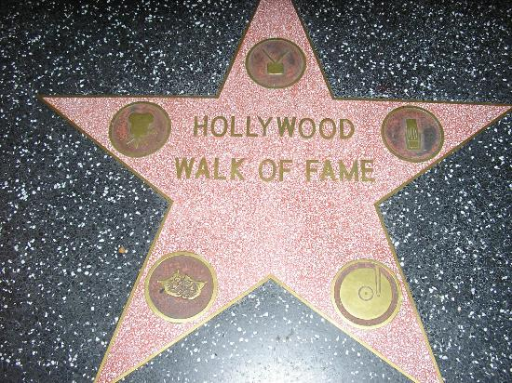
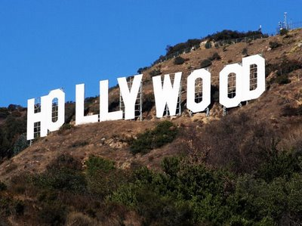
Hollywood is a district of the city of Los Angeles in the state of California. Due to its fame and identity as the historical center of movie studios, the word "Hollywood" is often used as a synonym for the American film industry and television. Many historic Hollywood theaters are used for several movie premieres and other performances. It is a popular destination for good nightlife and tourism, while there is also the avenue Walk of Fame. The area's population is estimated to be 300,000. Most years old were community of Indians. In 1870, an agricultural community settled in the area of prosperity and why the good weather in the area. The name came from Hollywood Hobart Johnstone Whitley and his wife Gigi where they thought the name in 1886 to their honeymoon. The Hobart bought from landowner of the area 500 acres to build the city imagined. The Harvey Wilcox, the first landowner in the area, drew a map for a town, which he filed in the office of the county recorder in County February 1, 1887 under the name Hollywood. That was the first official document that had the name Hollywood. Dozens of channels, movie studios and other companies making Hollywood as a film camera where in recent years is the number of 250 films a year.

Every year people arrive full of dreams who want to become movie stars. This is a problem that has existed since 1960 and few people are professional actors while many of those who did not turn back, they end up homeless. Big problem there and several young girls, or become prostitutes, or take part in pornographic films.

